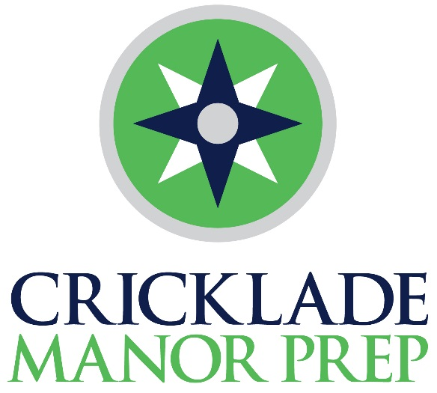

U11 Hockey Tournament
Wednesday 4th March 2020
1:30pm arrival - 2:00pm Start

Calcutt Street, Cricklade
Wiltshire SN6 6BB
T: 01793 750 275
E: prep@thepriorfoundation.com
www.thepriorfoundation.com

3-13 IAPS Boarding and Day Established
Co-educational Catholic Preparatory School
We would like to welcome all players and supporters to our Cricklade Manor Prep School U11 Hockey Tournament.
We are delighted to be able to offer pupils a friendly but competitive environment in which to play.

We wish everyone an enjoyable afternoon.
Tournament rules:

- Standard rules of 7-a-side In2Hockey will apply.
- Matches are 10 mins one way with a 2 minute turn around between games.
- Umpire own matches with the 1st named team to supply a ball.
- Coaches are responsible for their own first aid.
- Matches start and finish on Umpire’s whistle (no central timing).
- Scoring will be as follows: 3 points for a win, 2 for a score draw, 1 for a no score draw and 0 for a loss.
- In the event of a tie the winner will be decided on goal difference.

After the final matches a snack for all of the players will be available from the Pavilion followed by a presentation. Light refreshments will be available in the Pavilion for all supporters from 3:00pm.

1. Cricklade Manor Prep
2. The Paragon
3. Cheltenham
4. King’s Gloucester
5. Beaudesert
6. Dean Close
7. Heywood

 | Pitch 1 | Pitch 2
2:00pm | The Paragon vs CMP | Cheltenham vs King’s Glos
2:12pm | King’s Glos vs Dean Close | Heywood v Cheltenham
2:24pm | Dean Close vs Beaudesert | Heywood v The Paragon
2:36pm | Beaudesert vs The Paragon | CMP vs King’s Glos
2:48pm | The Paragon vs King’s Glos | CMP vs Cheltenham
3:00pm | Heywood v Beaudesert | Dean Close vs CMP
3:12pm | Beaudesert vs Cheltenham | Heywood v King’s Glos
3:24pm | Dean Close vs The Paragon | Beaudesert vs King’s Glos
3:36pm | Heywood v CMP | Cheltenham vs Dean Close
3:48pm | Cheltenham vs The Paragon | CMP vs Beaudesert
4:00pm | Heywood v Dean Close
4:15pm | Presentation

